 Jain College of Engineering and Research Belagavi

## DBMS Mini Project on :

## “Blood Bank Management System”

Prepared by :-

Xavier .E. Dias 2JR19CS098

Project Title: Blood Bank Management System

# Problem Statement: To design and develop a Blood Bank Management System is to ease the process of current blood donation process and to have a good user interface.

WEB PAGE DESIGN- SCREENSHOTS

HOME PAGE:

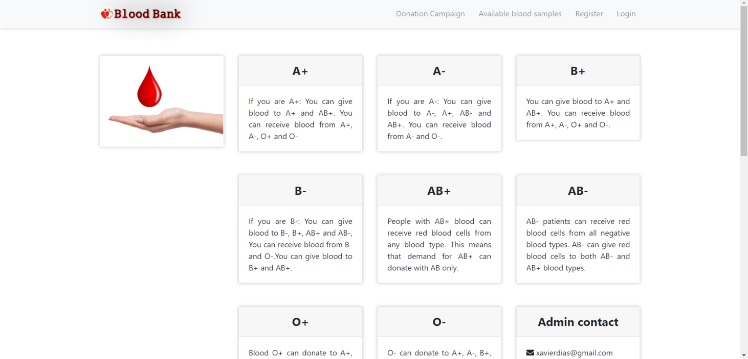

REGISTRATION PAGE:

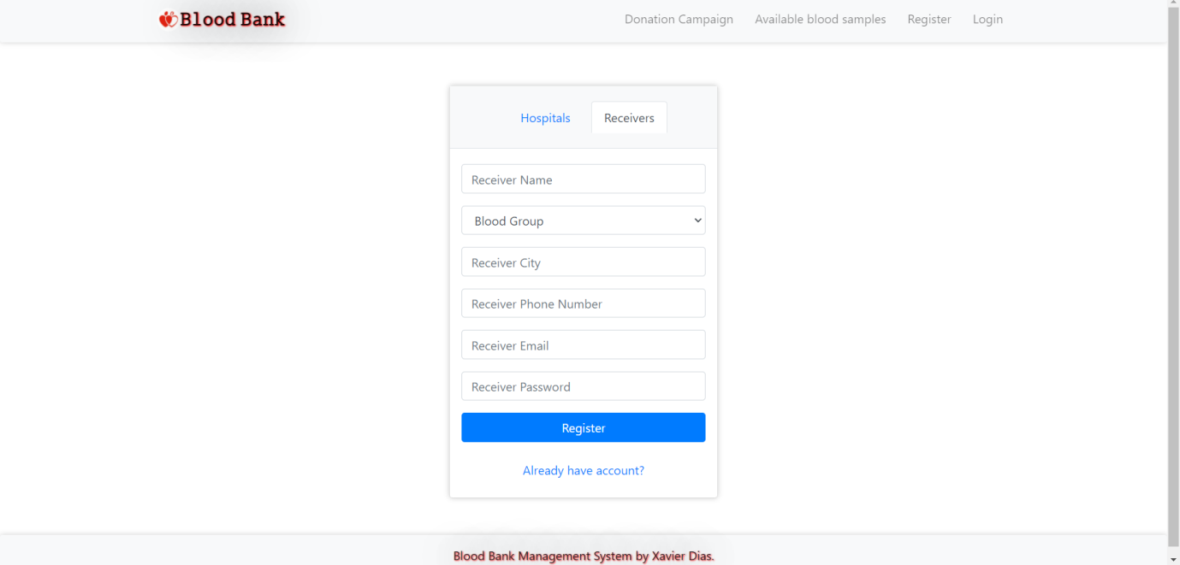

LOGIN PAGE:

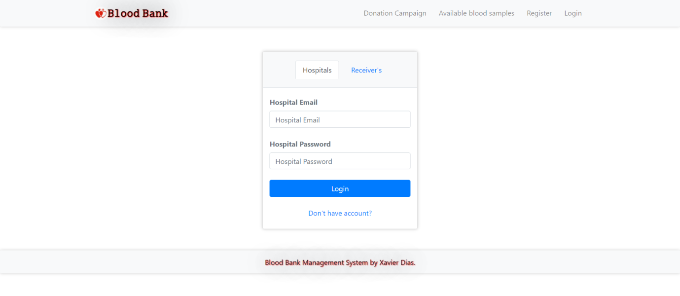

ADMIN DASHBOARD:

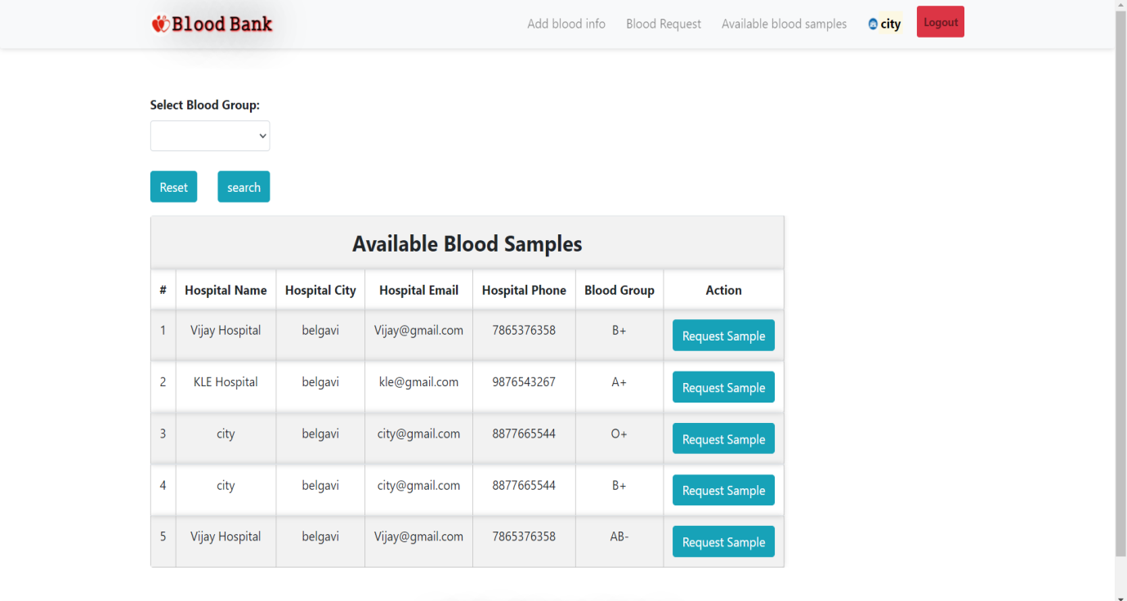

ADMIN DASHBOARD:

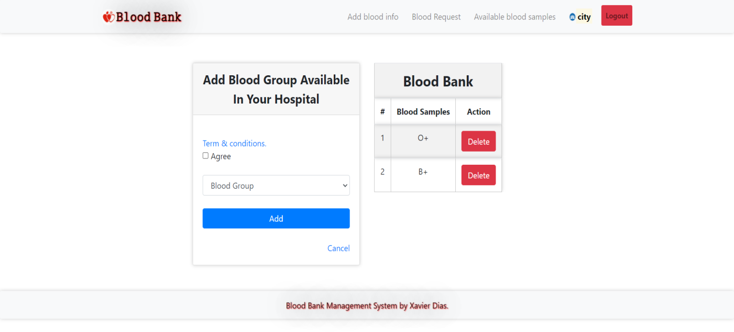

BLOOD REQUESTS:

